Benchmarking GNNs, DLs, and MLs for Neurological Disorder Classification
1. Introduction & Background
The human brain is an extremely complicated network that comprises regions both anatomically and functionally interconnected. In other words, the "connectome" of the brain can be mathematically represented as a graph where nodes are equivalent to regional brains and edges encode functional or structural connections between these areas. Variations in its topology have been associated with numerous neurological and psychiatric maladies; for instance, Alzheimer's disease (AD), Autism spectrum disorder (ASD), or Parkinson's disease among others. In standard applications of ML and DL to neuroimaging data, the associated connectivity matrices are vectorized whereby crucial topological information is often lost. On the other hand, since GNNs were conceived specifically for graph-structured data they can make use of explicit connectome structure information leading possibly to models that are not only more accurate but also much closer biologically for disease classification.
2. Problem Statement
Though there have been large-scale studies that applied ML, DL, and GNNs to brain connectome data across different datasets, rigorous-standardized benchmark studies comparing these paradigms on the same datasets with identical preprocessing and evaluation protocols are missing. In addition, hybrid approaches composed of GNN embeddings followed by classical anomaly detection methods have not been much discussed.
- Primary Research Question: Which modeling paradigm between Classical ML, DL, and GNN can achieve high accuracy and robustness in neurological disorder classification from functional brain connectomes?
- Secondary Question: Can a hybrid pipeline that leverages embeddings produced by GNNs with classical anomaly detectors provide a better trade-off between accuracy and computational efficiency
3. Objectives
- Implementing and evaluating these representative models from three families:
  - Classical ML: Support Vector Machine (SVM), Random Forest (RF)
  - Deep Learning (DL): Multi-Layer Perceptron (MLP), 1D-Convolutional Neural Network (CNN)
  - Graph Neural Networks (GNN): Graph Convolutional Network (GCN), Graph Attention Network (GAT)
- Designing and evaluating a hybrid pipeline where graph embeddings from pre-trained GNNs serve as features for classical anomaly detection algorithms such as Isolation Forest or One-Class SVM.
- Conducting robustness analyses including simulated sensor drop-outs and cross-dataset generalization (training on ADNI, testing on ABIDE).

4. Literature Review
Functional connectivity patterns derived from neuroimaging data have demonstrated moderate efficacy in the differential diagnosis of neurological disorders when applied to classic machine learning models, e.g., support vector machines on flattened connectome vectors. Deep learning approaches involving convolutional neural networks interpret adjacency matrices as images through which hierarchical features may be learned, yet problems exist with respect to node ordering and spatial consistency. Very recently, GNNs have been shown to be highly appropriate for graph data by extracting information from graph topology. However, studies differ considerably in their datasets and preprocessing fragmentation impeding direct comparison. This proposal thus responds to such fragmentation with a systematic and reproducible benchmarking study across methods.

5. Methodology
5.1 Dataset
- Primary: Alzheimer’s Disease Neuroimaging Initiative (ADNI) – AD vs. Healthy Controls (HC)
- Secondary: Autism Brain Imaging Data Exchange (ABIDE) – ASD vs. Typically Developing (TD)
5.2 Data Preprocessing & Graph Construction
- Download resting-state fMRI data and segment brains into 116 Regions of Interest (ROIs) using the Automated Anatomical Labeling (AAL) atlas.
- Extract ROI time series per subject.
- Compute Pearson correlation matrices as adjacency matrices representing functional connectivity; explore alternative metrics for robustness.
- Use each node’s correlation profile as node features. Additional features may be incorporated if feasible.

5.3 Model Design & Implementation
- Classical ML: Flatten upper triangle of adjacency for SVM and Random Forest.
- DL: MLP and 1D-CNN with flattened connectivity vectors as input.
- GNN: Use PyTorch Geometric to build GCN and GAT models operating on graph input (node features and adjacency). Apply global mean pooling for classification embeddings.
5.4 Hybrid Pipeline
- Extract graph-level embeddings from pre-trained GNN models.
- Use these embeddings to train classical anomaly detectors (Isolation Forest, One-Class SVM).
5.5 Evaluation
- Perform Stratified 5-Fold Cross-Validation with consistent splits across methods.
- Evaluate using Accuracy, Precision, Recall, F1-Score, AUC-ROC, confusion matrices, and statistical significance testing.
- Record training and inference times for computational efficiency comparison.
5.6 Robustness Testing
- Simulate sensor dropout by masking node features randomly during testing.
- Test cross-dataset generalization by training on ADNI and evaluating on ABIDE.
- Optionally include adversarial perturbation and domain adaptation methods if time permits.

6. Expected Outcomes
- A full numerical rating of old ML, DL, and GNN methods on working brain link data.
- Thoughts on, if keeping shape and detail in GNN leads to better sorting results in health use.
- Check of mixed models’ power to keep both exactness and speed of math work.
- Top tips for strength in health brain net study. Free code bank making sure things can be done again and helping later checks.

7. Timeline & Resources
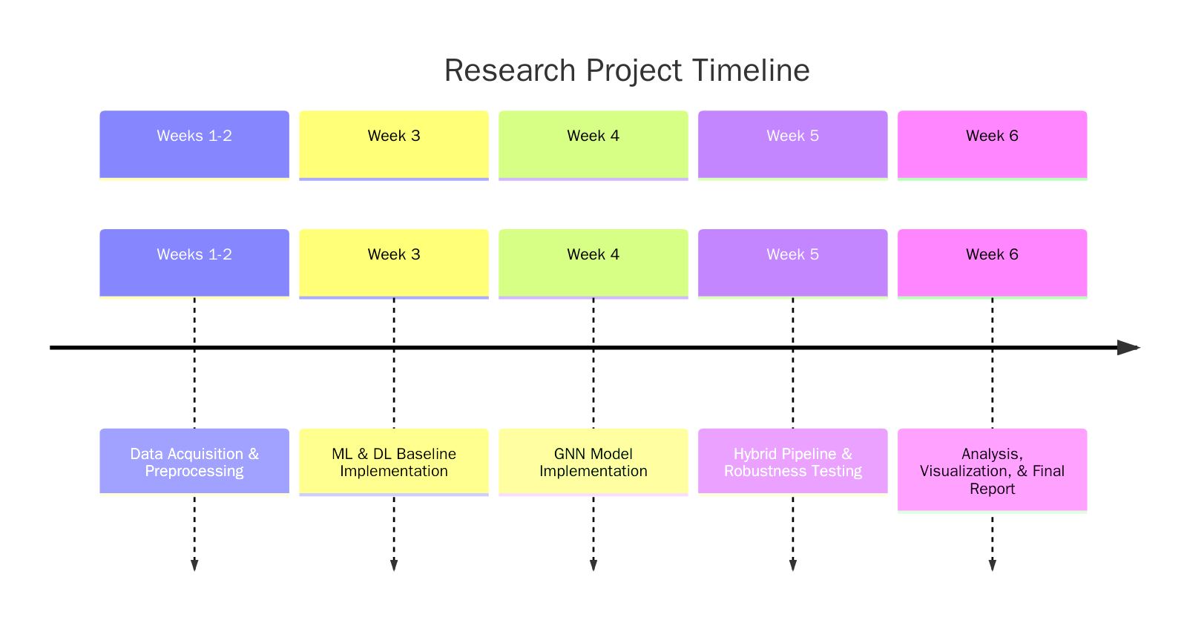

Resources:
- Datasets: ADNI, ABIDE
- Libraries: Python, PyTorch, PyTorch Geometric, scikit-learn, Nilearn, NumPy, Pandas, Matplotlib, Seaborn.
- Hardware:
  - GPU: (NVIDIA RTX 3060 12GB DDR5 VRAM), optional cloud credits (Colab Pro) for scale.
  - CPU: Ryzen 7 5700X 8 Core, 16 Thread Processor
  - RAM: 32 GB DDR4
  - SSD: 500GB GEN-4 SSD
  - Access to cloud in needed(Colab Pro etc).

8. Ethical Considerations & Limitations
- Strict observation of patient data privacy regulation and dataset licensing.
- Acknowledge dataset biases as well as inter-site variability.
- Computational and methodological limitations, though carefully cross-validated, reproducible pipelines.

9. References
[1] Kim, H., Lee, B. S., Shin, W.-Y., & Lim, S. "Graph Anomaly Detection with Graph Neural Networks: Current Status and Challenges," arXiv:2209.14930, Sep. 2022.
[2]
[3] Pang, G., Shen, C., Cao, L., & van den Hengel, A. "Deep Learning for Anomaly Detection: A Review," ACM Computing Surveys, vol. 54, no. 2, Mar. 2021.
[4] Mihăiţă, A.-S., Li, H., & Rizoiu, M.-A. "Traffic Congestion Anomaly Detection and Prediction Using Deep Learning," arXiv:2006.13215, Jun. 2020. (Note: Methodology for DL is transferable).
[5] Gao, Y., Zhu, Q., Shi, X., & Jin, H. "A Transformer-Based Spatio-Temporal Graph Neural Network for Anomaly Detection on Dynamic Graphs," in Big Data, Springer, Jan. 2025. (Relevant for advanced spatio-temporal modeling).
[6] Schummer, P., del Rio, A., Serrano, J., et al. "Machine Learning-Based Network Anomaly Detection: Design, Implementation, and Evaluation," AI, vol. 5, no. 4, 2024.
[7] Sattar, S., Khan, S., Khan, M.I., et al. "Anomaly Detection in Encrypted Network Traffic Using Self-Supervised Learning," Scientific Reports, vol. 15, 2025. (Relevant for hybrid/unsupervised approaches).

